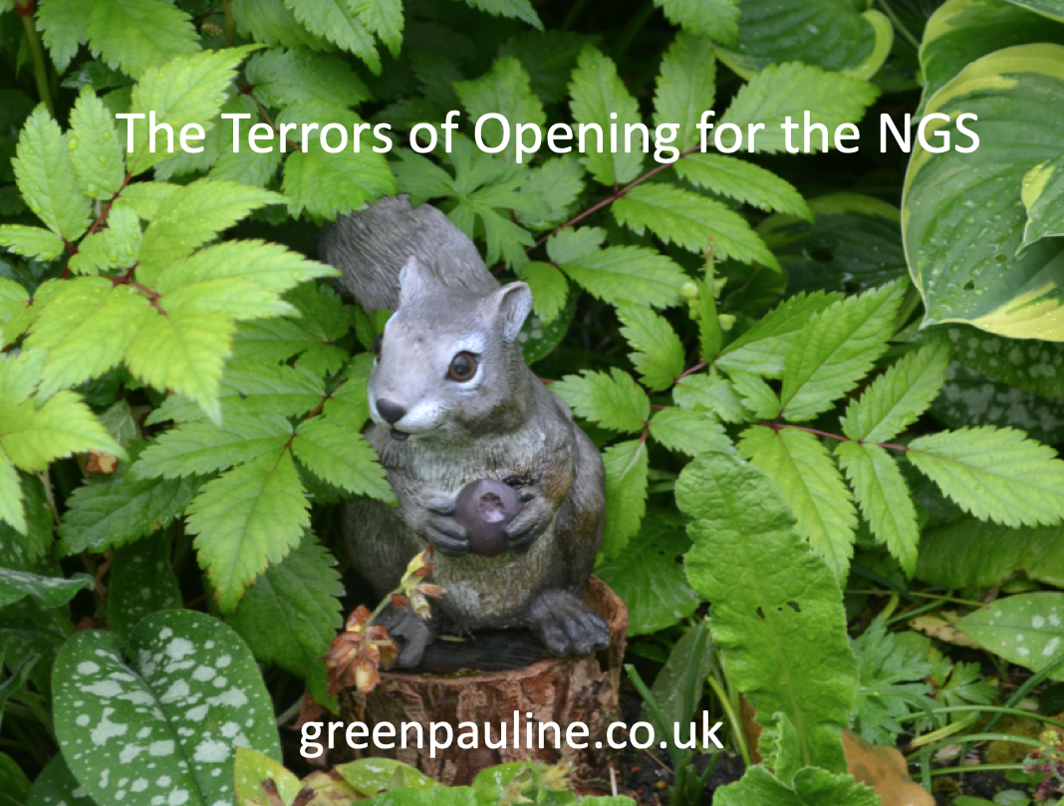
The Terrors of Opening for the NGS
The good the bad and the truly ugly (Rather rude in places…)

time day date location post code
Name of your club
Contact us on ……
Free to members. £ to non-members

We are delighted to have Pauline talking to us.
Pauline is a keen gardener and painter who is passionate about sustainability and gardening for wildlife. When she is not covered in soil or paint, she helps people to get into gardening and nature, sharing advice and resources.

Pauline is very experienced with many qualifications.

- RHS Diploma in Horticulture from Sparsholt College
- 30 years of experience as a gardener and designer
- Opened for the National Garden Scheme several times
- Winner of Peter Maunder Hampshire Federation of Horticultural Societies Best Garden 2013
- Speaker to various clubs and societies
- Fellow of The Linnaean Society
- FSC Cert' Bee Nesting Ecology & Conservation June 2022

